Note: This document is “view only”. Please create a copy of this document and save it to your drive.

**SOP- Creating Client Project in PM Tool- Systems Vault**

**PREREQUISITES**

[Project Management Tool- Teamwork](http://sarahnoked.com/teamwork)

[Guidelines: Naming Conventions](https://docs.google.com/document/d/1IsYwJoykfoADN6hC3jGEgms5vz92vpVEAHWlxIMMJW8/edit?usp=sharing)

[Master: Client Details](https://docs.google.com/spreadsheets/d/1jHG9MEvCmCceeMhdQoOiuUFtzoz0OX240_Fw3Km_i98/edit?usp=sharing)

[SOP- MASTER Client Onboarding- Systems Vault](https://docs.google.com/document/d/1h15rYHmTzGFdfzso_DxqyYtqkFcpNlM8DWo4YLwYBn4/edit?usp=sharing)

**PURPOSE**

To add a client project into [Project Management Tool- Teamwork](http://sarahnoked.com/teamwork) once they’ve signed with us. At this point, we’ve not yet invited the client. We invite the client at a later stage.

**POLICY:**

Make sure the name of the project follows naming conventions: [Guidelines: Naming Conventions](https://docs.google.com/document/d/1IsYwJoykfoADN6hC3jGEgms5vz92vpVEAHWlxIMMJW8/edit?usp=sharing)

**PARTY**

Virtual Assistant

**PROPERTY**

Online Business Manager

**PROCESS:**

Part 1: Create Client Company

Part 2: Create Project

Part 3: Turn on Integrations with Harvest, Google Drive

Part 4: Invite client to Teamwork Project

Part 5: Set up Teamwork email address for client  
Part 6: Update phone number and localization settings for the client in Teamwork

**PROCEDURES**

**Part 1: Create Client Company**

1. Log in to Teamwork
2. Click on People> Add Company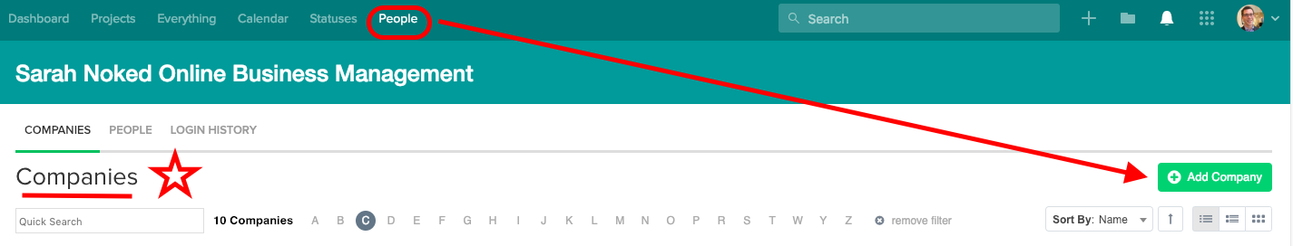
3. Enter company name and save

**Part 2: Create Project**

1. Navigate to ‘Add Project’



1. Name project according to naming conventions [SN Guidelines: Naming Conventions](https://docs.google.com/document/d/1IsYwJoykfoADN6hC3jGEgms5vz92vpVEAHWlxIMMJW8/edit?usp=sharing)
2. Toggle over to the “Company” tab >> Define the project as for an external company

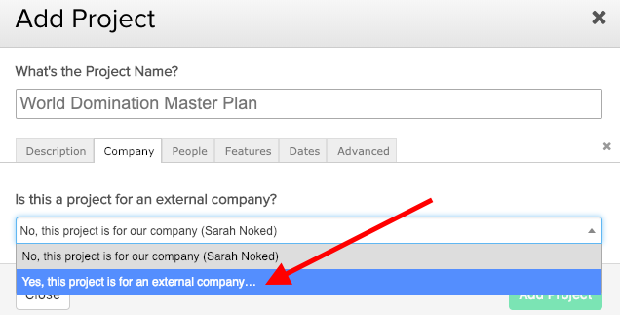

1. Click ‘Add Project’
2. Delete Ongoing Tasks and Recurring Tasks lists and leave only the Inbox task list.

**Part 3: Turn on Integrations with Harvest and Google Drive**

1. Click on project settings
2. Make sure that in the integrations tab, both Google Drive and Harvest are toggled to ‘on’ (green)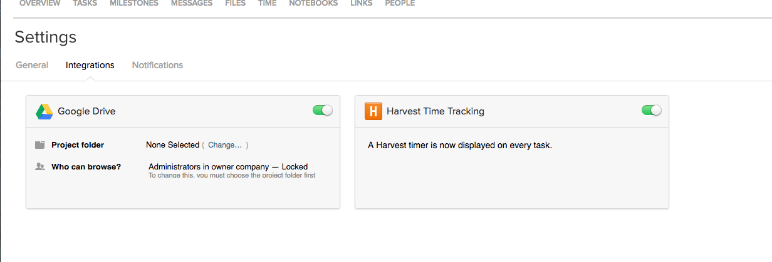’
3. In the Google Drive Section, under ‘Project folder’ select the client folder (that was set up under Google Drive > ‘Teamwork’ > ‘2. Client Folders’ and when prompted select ‘All People on the project’ to view
   1. 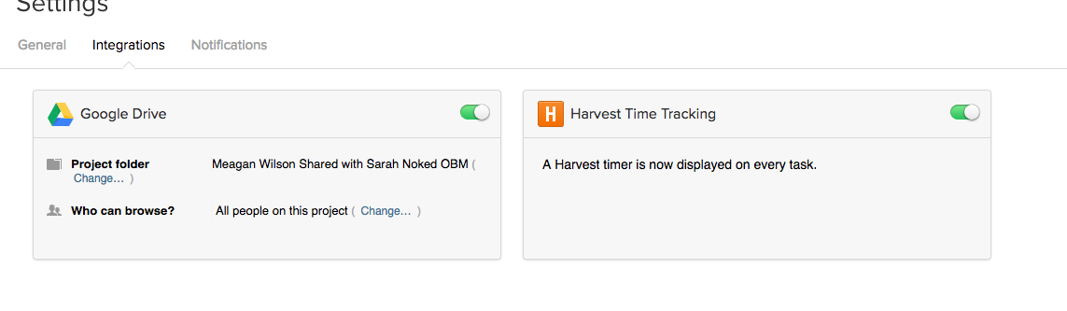
   2. 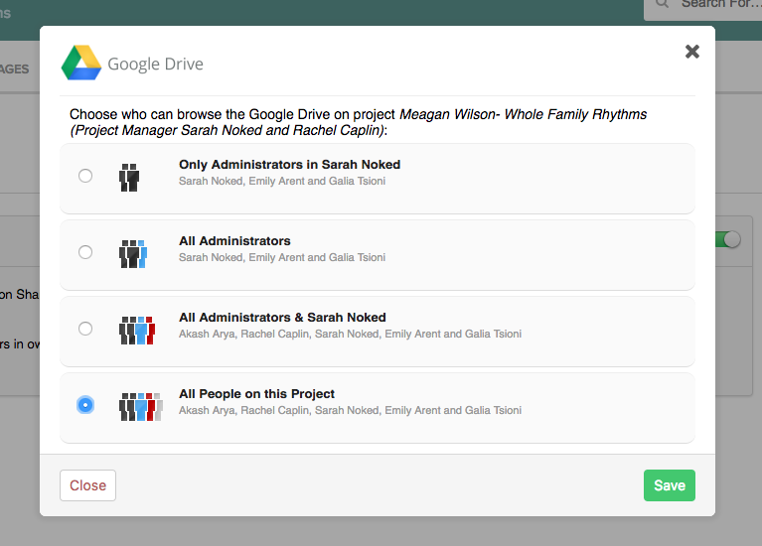

**Part 4: Invite the client to Teamwork Project**

1. Within client project > select “People” 
2. Click “Add People”
3. “Click “Invite New User”
4. Make sure they belong to their own company as a standard user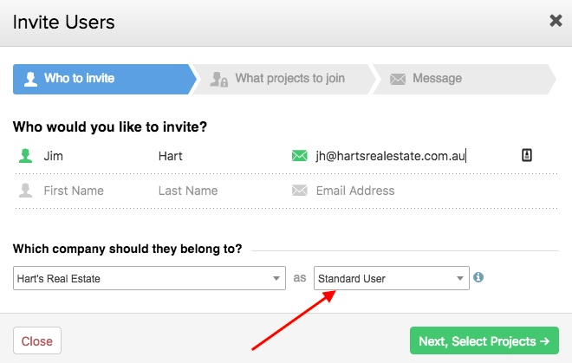
5. Define the client’s Teamwork Permissions and then click “Next, write message”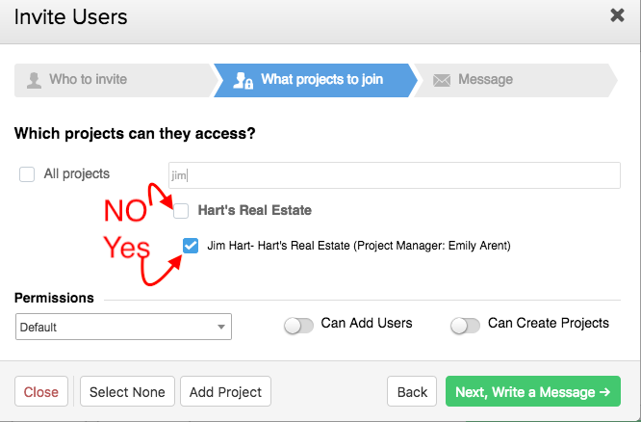
6. Our canned invite message will appear, click “Send invite to 1 person” and you’re DONE :)

**Part 5: Create Teamwork email account for client** (ONLY NECESSARY IF THEY ARE USING OUR TEAMWORK -- NOT IF THEY HAVE THEIR OWN PM PLATFORM)

1. In the tasks tab > 3 dot icon > Post Tasks via email
2. Edit > customize project email > firstnamelastname

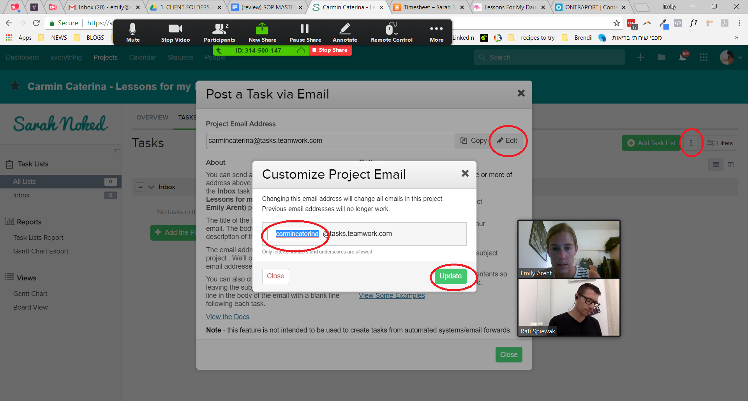

1. Add client phone numbers to teamwork in contacts, make sure the client time zone is set up correctly. This information can be found in Ontraport under client details (ONLY NECESSARY IF THEY ARE USING OUR TEAMWORK -- NOT IF THEY HAVE THEIR OWN PM PLATFORM)
   1. Within the client project, navigate to people
   2. Select the client and “edit”
   3. Put in their phone number under “Details” >> log into OP > Contacts > All > search client name > open contact record > phone number is on first page of contact record.
   4. Customize their Localization settings under “Localization” depending on if they are American, European, Israeli >> and update their timezone.

**Created by:**

**Department:** Delivery

**Date:**

**Revised:**

**Revised by:**